**DLD Lab 07 – In-Lab Tasks**

**Task 1(a)**

**Half Adder:**

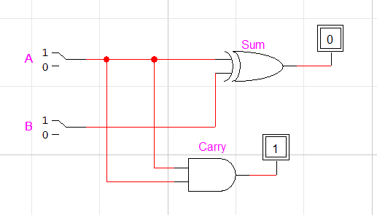

|  |  |  |  |
| --- | --- | --- | --- |
| **A** | **B** | **Sum** | **Carry** |
| 0 | 0 | 0 | 0 |
| 0 | 1 | 1 | 0 |
| 1 | 0 | 1 | 0 |
| 1 | 1 | 0 | 1 |

**Task 1(b)**

**Half Subtractor:**

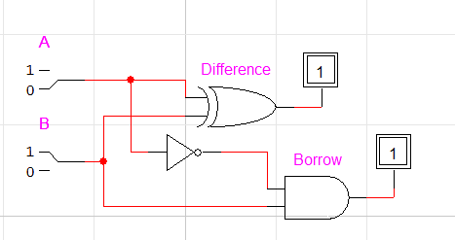

|  |  |  |  |
| --- | --- | --- | --- |
| **A** | **B** | **Difference** | **Borrow** |
| 0 | 0 | 0 | 0 |
| 0 | 1 | 1 | 1 |
| 1 | 0 | 1 | 0 |
| 1 | 1 | 0 | 0 |

**Task 2(a)**

**2 Bit Binary Multiplier**

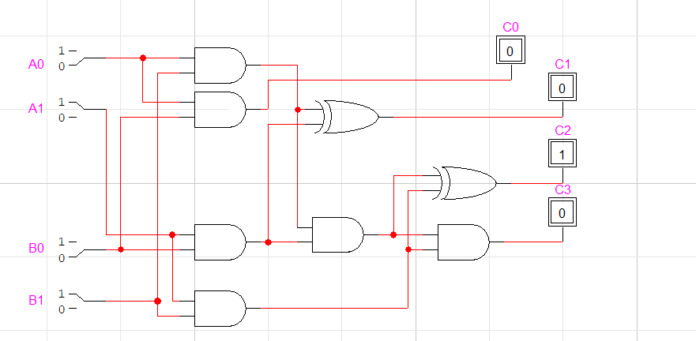

|  |  |  |  |  |  |  |  |
| --- | --- | --- | --- | --- | --- | --- | --- |
| **A1** | **A0** | **B1** | **B0** | **C3** | **C2** | **C1** | **C0** |
| 0 | 0 | 0 | 0 | 0 | 0 | 0 | 0 |
| 0 | 0 | 0 | 1 | 0 | 0 | 0 | 0 |
| 0 | 0 | 1 | 0 | 0 | 0 | 0 | 0 |
| 0 | 0 | 1 | 1 | 0 | 0 | 0 | 0 |
| 0 | 1 | 0 | 0 | 0 | 0 | 0 | 0 |
| 0 | 1 | 0 | 1 | 0 | 0 | 0 | 1 |
| 0 | 1 | 1 | 0 | 0 | 0 | 1 | 0 |
| 0 | 1 | 1 | 1 | 0 | 0 | 1 | 1 |
| 1 | 0 | 0 | 0 | 0 | 0 | 0 | 0 |
| 1 | 0 | 0 | 1 | 0 | 0 | 1 | 0 |
| 1 | 0 | 1 | 0 | 0 | 1 | 0 | 0 |
| 1 | 0 | 1 | 1 | 0 | 1 | 1 | 0 |
| 1 | 1 | 0 | 0 | 0 | 0 | 0 | 0 |
| 1 | 1 | 0 | 1 | 0 | 0 | 1 | 1 |
| 1 | 1 | 1 | 0 | 0 | 1 | 1 | 0 |
| 1 | 1 | 1 | 1 | 1 | 0 | 0 | 1 |